**Name: Asfand Yar**

**Roll Number: 18-10689**

**Tutor: Dr. Nosheen Sabahat**

**Course: Web App Development**

**Assignment 2**

**Running Image:**

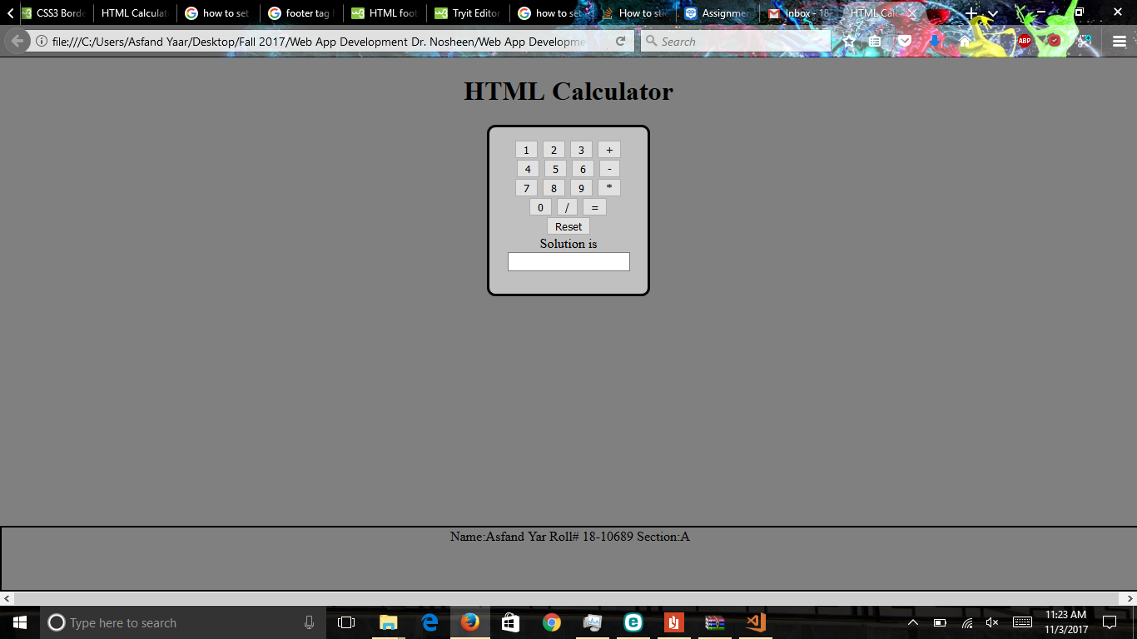

**HTML Code:**

<!doctype html>

<html>

<head>

<h1><strong></strong><center>HTML Calculator</strong></h1> <!--Heading-->

<title>HTML Calculator</title> <!--Title of tab-->

<script src="error_checking.js"></script> <!--Reference to external js file-->

<meta name="viewport" content="width=device-width, initial-scale=2">

<link rel="stylesheet" href= "calculator style.css"> <!--Reference to external css file-->

</head>

<center> <!--Will position the calculator at center of page-->

<div class="calculator">

<body class="calc_body" >

<form name="calculator" >

<center>

<input type="button" value="1" onClick="document.calculator.ans.value+='1'">

<input type="button" value="2" onClick="document.calculator.ans.value+='2'">

<input type="button" value="3" onClick="document.calculator.ans.value+='3'"> <!--Setting the Display value and Real Value of Calculator's Buttons-->

<input type="button" value="+" onClick="document.calculator.ans.value+='+'">

<br>

<input type="button" value="4" onClick="document.calculator.ans.value+='4'">

<input type="button" value="5" onClick="document.calculator.ans.value+='5'"> <!--Setting the Display value and Real Value of Calculator's Buttons-->

<input type="button" value="6" onClick="document.calculator.ans.value+='6'">

<input type="button" value="-" onClick="document.calculator.ans.value+='-'">

<br>

<input type="button" value="7" onClick="document.calculator.ans.value+='7'">

<input type="button" value="8" onClick="document.calculator.ans.value+='8'"> <!--Setting the Display value and Real Value of Calculator's Buttons-->

<input type="button" value="9" onClick="document.calculator.ans.value+='9'">

<input type="button" value="*" onClick="document.calculator.ans.value+='*'">

<br>

<input type="button" value="0" onClick="document.calculator.ans.value+='0'"> <!--Setting the Display value and Real Value of Calculator's Buttons-->

<input type="button" value="/" onClick="document.calculator.ans.value+='/'">

<input type="button" value="=" onClick="document.calculator.ans.value=eval(document.calculator.ans.value)"><!--Will calculate the answer and save it to value attribute of = Button-->

<br><input type="reset" value="Reset">

<br>Solution is <input type="textfield" name="ans" value=""> <!--Will display the result stored in value attribute of =-->

</form> <!--Closing the form tag-->

</div> <!--Closing the div tag-->

</body> <!--Closing the body tag-->

<footer class="ftr">Name:Asfand Yar Roll# 18-10689 Section:A </footer> <!--Footer with Name and Roll Number-->

</html>

**CSS File Code:**

.calculator {

position: relative; /*This block of code will give styles to the inner body of calculator*/

width: 160px;

height: 170px;

background-color:silver; /* Color of inside body of calculator will be silver*/

border: solid black 3px;

padding:15px;

border-radius:10px; /* Will make the corners of calculator round-shaped*/

}

.calc_body{

background-color: gray; /*Background color of document will be grey*/

}

.ftr{

position: absolute; /* This block of code is for positioning the footer at bottom*/

left: 0;

bottom:0;

height: 75px;

width: 100%;

border: solid black 2px;

}